Unit 7 – Lesson 1. Conditional Probability and Fair Game

Aim: What is conditional probability and how do we calculate probability?

Objectives: After the lesson, students should be able to:
- Solve conditional probability problems

References:
- Unity 5.x Game AI Programming Cookbook, Palacios
- Cornell University, AI and Game Programming, Conditional Probability
http://www.math.cornell.edu/~mec/2008-2009/TianyiZheng/Conditional.html

- Online probability and math resources
  - http://www.onlinemathlearning.com/conditional-probability.html
  - http://www.shodor.org/interactivate/lessons/ConditionalProb/
  - http://nrich.maths.org/public/leg.php?code=-76

CLASS PROCEDURE:
Do Now:

Go to http://setosa.io/conditional/,
try the simulation. Do you think the simulation can help you to visualize conditional probabilities? Why and why not?

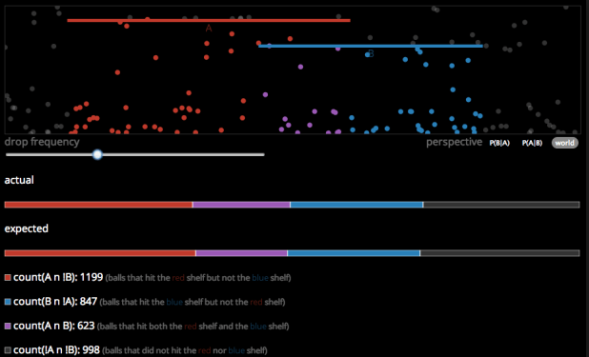

You can drag the red and blue bars to change the lengths of the bars.

Class Discussion / Presentation: Diagrams to describe conditional probabilities

Here are some diagrams describing conditional probabilities in a visual way:

- Tree diagram:

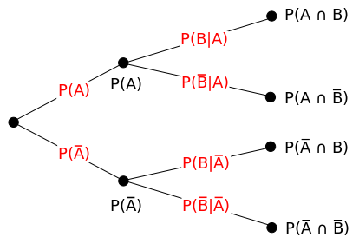

Example:
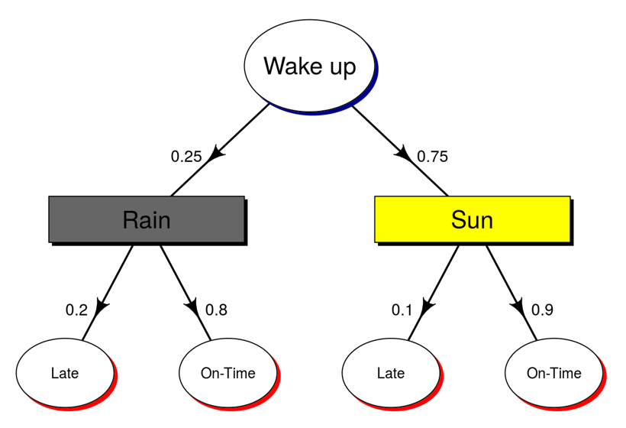

- Pie diagram:
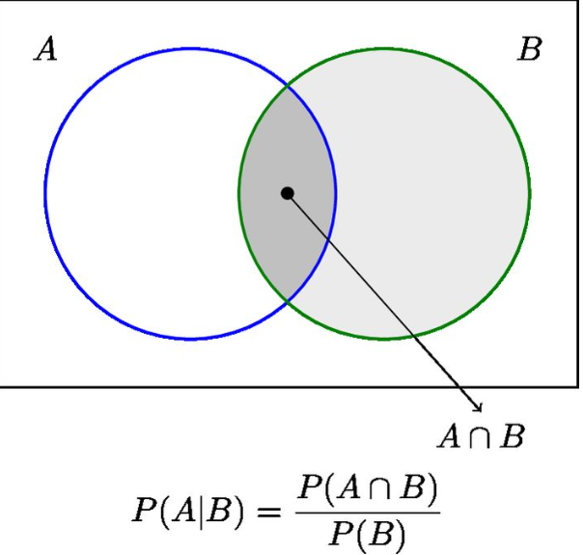

Example:

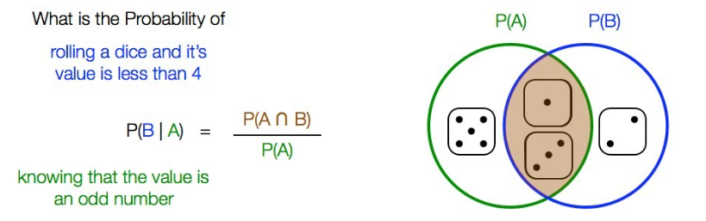

In your Board Game project, did you use conditional probabilities? Did you use any diagram to help you design the AI if you used conditional probability?

Pair – sharing Activity: Horse racing with two dice.
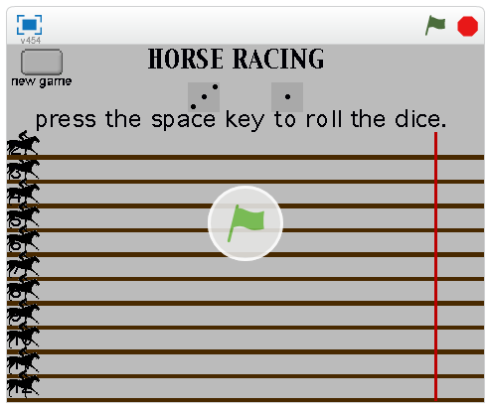

Here’s the link to the simulation:

https://scratch.mit.edu/projects/743714/

- Work with your partner, calculate the winning probability for each horse.

- Is this a fair game? Why?

- How do we define fair and unfair?

- When you design a game, do you want to make your game fair or unfair?

- Have we seen any fair game and unfair game in the Board Game AI project presentation?

Pair – sharing Activity #3:
Work with your partner and write a two page design document for your final game project. Your design shall include the following:
- Game Description and Target Audience
- Game Rules Description
- Game Play / Storyboard
- Graphics Design (hand drawing is acceptable)
- High Level Game Design (Class Hierarchy Diagram and Flowchart)
- Platform for Build

